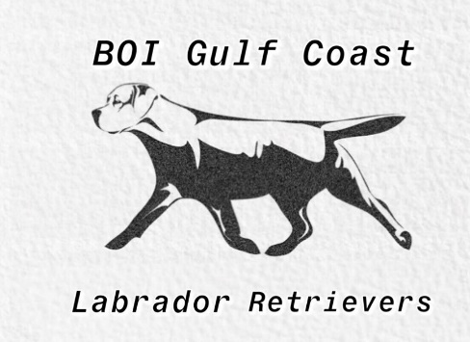 BOI Gulf Coast Labradors
Gregory Szanyi
7200 Bar O Ranch Rd Santa Fe, TX
(281)-615-4188, (832)-782-8634
boigulfcoastlabradors@gmail.com

Date of Mating:____/_____/_______ Date of Preg. Confirmation:_____/_____/_______
Male AKC Name and Number:_____________________________________________
Female AKC Name and Number:___________________________________________
Name of Bitch Owner:____________________________________________________
Address:___________________________________Phone:______________________
If semen is shipped...
Name & Address of Veterinarian used (where semen is to be shipped):_____________
______________________________________________________________________
BREEDING OPTIONS...
Natural and artificial breeding’s are available. If the bitch is to be brought to the
stud in person, both live cover and side by side artificial insemination (AI) are available.
If the bitch cannot be brought to the stud for an in-person breeding, semen will have to
be shipped. Stud Fee is $1800-$2000 depending on stud used.
BITCH REQUIREMENTS...
For a bitch to be considered to breed to a stud at BOI Gulf Coast Labradors, a copy
of the bitch’s pedigree and proof of any health testing done must be provided to the stud
owner prior to the day of mating. The bitch must also be in good health and current on
all age necessary vaccinations. If the bitch has had a litter prior, a brucellosis test is to
be done within ten days prior to the day of mating by a licensed veterinarian, and proof
of testing must be provided to the stud owner, prior to the day of mating. (Brucellosis is
not required if semen is to be shipped, but is highly recommended) Without all of these
qualifications being met, breeding will not take place.
IF PICK OF LITTER IS AGREED UPON...
If pick of litter is agreed upon by stud owner and bitch owner, the stud owner is to
be given pick of all puppies before anyone, including the owner of the bitch. The bitch
owner is required to let the stud owner know when the first and last puppy is born.

